**Project: SKY NET**

**System Specification**

***Presented by***

Futuristic Innovative Technologies

cFOUO For Official Use Only: Controlled Unclassified Information

**FIT Participating Members:**

Andrew Thomas, Spenser Gorenflo, Connor Hill

Dhwanil Desai, Nisarg Shah, Miles Medearis, Yaya Nedd, Mariana Villalabeitia Arenas

Dylan Huss, Bria Booth, Suleyman Gokdemir

|  |  |  |
| --- | --- | --- |
| **Rev.** | **Date** | **Revision Notes** |
| 0 | 08/23/2021 | Initial Release by FIT |
| 1 | 09/30/2021 | Update Requirements, updated section 3.1.4 Functional Analysis Section |
| 2 | 11/18/2021 | Updated Scope, System Requirements, CONOPS, Qualification Study, Added Requirements Justifications Appendix |

***Table of Contents:***

1. Scope 4

2. Applicable Documents 5

3. System Requirements 6

3.1. System Definition 6

3.1.1. General Description 6

3.1.2. Operational Requirements 6

3.1.3. Maintenance Concept 8

3.1.4. Functional Analysis and System Definition 8

Requirements 10

3.1.5. Allocation of Requirements 12

3.1.6. Functional Interfaces and Criteria 13

3.2. System Characteristics 13

3.2.1. Performance Characteristics 13

3.2.2. Physical Characteristics 15

3.2.3. Effectiveness Requirements 16

3.2.4. Reliability 16

3.2.5. Maintainability 16

3.2.6. Usability (Human Factors) 17

3.2.7. Supportability 17

3.2.8. Transportability / Mobility 17

3.2.9. Flexibility 17

3.2.10. Sustainability 18

3.2.11. Safety 18

3.3. Design and Construction 19

3.3.1. CAD/CAM Requirements 19

3.3.2. Materials, Processes, and Parts 19

3.3.3. Mounting and Labelling 19

3.3.4. Electromagnetic Radiation 19

3.3.5. Interchangeability 20

3.3.6. Workmanship 20

3.3.7. Testability 20

3.3.8. Economic Feasibility 20

3.4. Documentation / Data 20

3.5. Logistics 20

3.5.1. Maintenance Requirements 21

3.5.2. Supply Support 21

3.5.3. Test and Support Equipment 21

3.5.4. Personnel and Training 21

3.5.5. Facilities and Equipment 21

3.5.6. Packaging, Handling, Storage and Transportation 21

3.5.8. Technical Data 22

3.5.9. Customer Service 22

3.6. Producibility 22

3.7. Disposability 23

3.8. Affordability 23

4. Test and Evaluation 23

5. Quality Assurance Provisions 26

6. Distribution and Customer Service 26

7. Acronyms 27

8. References 28

# ***Scope***

****This preliminary system specification has been created as an addendum to the primary UAV System Specification document and is to be used for educational purposes. It does not capture the full system specifications, nor does it include system requirements outside of this system unless a modification has been identified to those systems for this system to be fully integrated.

The project scope is to integrate state-of-the-art ATC imaging capabilities with GPPP technology in real time into an AUAV. Its functions are to perform “search and find” maneuvers, conduct object of interest tracking, and include programming for threat aversion; operate both independently and as an autonomous integrated swarm of AUAVs with adaptive, AI-based decision-making/mission reconfiguration; and is adaptable for future features such as natural language, AI-based Command and Control Interface. and compensate for atmospheric turbulence imaging atmospheric aberrations and system noise and automatic target recognition. FIT will also create a feasibility study for the development of a Mobile Command Center (MCC), which will have the capability to be deployed indefinitely in remote low access areas. The main elements to be assimilated in this project are:

* A high-speed Atmospheric Turbulence Compensating (ATC) capability and General Purpose Parallel Processing (GPPP) technology.
* Capability to operate autonomously with Artificial Intelligence (AI) - based decision-making technology in “search and find” maneuvers and Object of Interest (OoI) tracking.
* A controller for individual or Autonomous Integrated Swarm (AIS) of autonomous AUAVs.
* The capability to operate an adaptable system to supplement other features or capabilities such as natural language, AI-based Command and Control Interface depending on the type of mission or environment it would operate on.
* A component-level detailed bottoms-up analysis for the power/energy support system for the mobile command center.

Additional integrated features proposed for the AUAV include a need to look like a generic ‘Search and Rescue’ UAV and be world-wide deployable. Specifically, the project is to provide desert, coastline, Alaskan wilderness search and rescue aptitudes; thus, a specific emphasis on adaptability to recognize hardships and defend itself due to very harsh and extreme environments and circumstances. The system should provide capabilities to either be autonomous or controlled remotely (“manual override” capability), and have the ability to conduct maintenance, upgrades, pre-planned product improvement, service, availability, and reliability etc.

# ***Applicable Documents***

The processes and standard operating procedures referenced within this specifications document:

* 1. Military Standards

MIL-STD-499 for SYSTEM ENGINEERING MANAGEMENT (17 JUL 1969).

* 1. Federal Aviation Administration (FAA) Standards

FAA part 107 Unmanned Aircraft Systems (UAS)

* 1. Federal Communications (FCC) Standards

47 CFR section 2.1 Aeronautical Mobile Route Service

ITU-R M.2171 *Characteristics of Unmanned Aircraft Systems and Spectrum Requirements to support their safe operation*

# ***System Requirements***

This section covers all functional, nonfunctional, human-centered, and applicable system life-cycle requirements.

## ***System Definition***

The AUAV is the system that is composed of several systems that accomplish specific functions in order to meet the mission needs. The system is mainly made of hardware and software components with logistics and maintenance support. The fully operational system has decision making abilities and it can be managed by certified operators with the proper training. The system has autonomous flying capability, automatic target recognition, atmospheric turbulence compensating imaging, “search and find” capabilities, collision avoidance, full flight control functions, real time data communication links, and other functions that allow the three-letter agency, Department of Homeland Security and other organizations to accomplish their specific mission.

### ***General Description***

The AUAV is an unmanned aerial vehicle system that flies autonomously over a target area in all terrains, environments, and climates. The AUAV system’s main task is to identify possible humans (bipedal) figures using its optical system and data processing in order to alert operators at the mission control center to conduct detention, search and rescue, among other operations as well.

### ***Operational Requirements***

The mission of the three-letter agency is to provide multi-purpose surveillance support for worldwide scientific collection activities, support low-profile data and information collection efforts for allies and national partners, conduct rapid worldwide deployments and surveillance activities in support of national treaty monitoring interests, and implement surveillance and reconnaissance missions for national strategic and tactical targets-of-interest (TOIs). The three-letter fosters science, innovative technology, and collaborations with strategic partners. It is not required that remotely operated continuously. The AUAV system will implement a state-of-the-art, Atmospheric Turbulence Compensating (ATC) imaging capability with an Automatic Target Recognition (ATR) feature that provides the fastest (real-time), and highest spatial resolution images available on the planet. This system is also capable of autonomous flight with "search and find" maneuvers and Object of Interest (OoI) tracking.

In order to address these needs, autonomous mission execution capabilities include an AI-based decision making system to perform solo missions with OoI and an imaging system that filters out any atmospheric aberrations and system noise. The AUAV system will also be able to be used in an Autonomous Integrated Swarm (AIS) of AUAVS - This will enhance their target area, data gathering/sharing, and decision making time. The main purpose of the AUAV system is to reallocate resources and reallocate manpower to higher level tasks.

By having autonomous and AI capabilities, the system will require less manpower. Once a target destination has been assigned or a mission programmed, it can depart on its own to its assigned flying target area and use its decision making capabilities to adapt to new conditions or information. The AUAV can send the data acquired (e.g. in the form of raw image files) continue to new target location once the data acquired was processed and transmitted to the mission control center for further analysis.

The AUAV system will be delivered to customers once the prototype has been fully developed, tested, and operational. The customer will send their current UAVs to our warehouse in order to implement what was already shown and tested and agreed by the customer. When system retirement is required, the customer will send back their AUAVs to Supplier decommissioning facility. Also, customer will allow Supplier engineers to decommission at their mission control center if required.

The AUAV system task, shown in the Concept of Operations (CONOPS) Figure 1, shows the concept of operations (CONOPS). The figure depicts the AUAV when operated as part of an autonomous, integrated swarm of AUAVs within the area of operations in the US – Desert, Coastline, and Alaskan wilderness Search and Rescue environment as well as world-wide terrains and climates. The AUAV will utilize Atmospheric Turbulence Compensating (ATC) imaging capability with Automatic Target Recognition (ATR) that will provide the fastest real-time, and highest spatial resolution images available. The AUAV will also be capable of autonomous flight with Search and Find maneuvers, and Object of Interest (OoI) tracking. The AUAV system will also be adaptable for additional capabilities, such as natural language, and an AI-based Command and Control Interface.

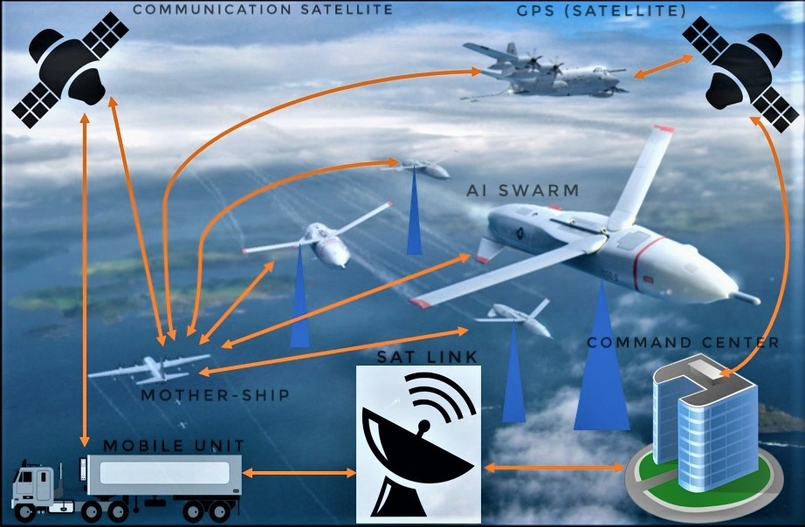

Figure 1: Concept of Operations (CONOPS)

This CONOPS focuses on the AUAV as it monitors a search area associated with a hot spot. The AUAV system will provide 24/7 detection coverage of up to 50 hot spots simultaneously, in a 100 Km2 observation area – with an expanded capability of a 169,737 Km2. This CONOPS also depicts the AUAV as it interacts with its guidance control measures, ground network, and in-flight operations relative to its inherent navigation dependence.

### ***Maintenance Concept***

Maintenance technicians from the customer will be properly trained and certified to perform preventative maintenance, diagnostics, repairs and servicing on site by the supplier. The AUAV system will support the function of updating firmware via transmission link with its mission control center. Also, the Supplier will provide a 24/7 customer support center, with highly trained engineers that can perform troubleshooting and are ready for dispatch if required by the customer.

### ***Functional Analysis and System Definition***

This section will provide a high-level description of the functional systems within the AUAV. The aim is to show the overall relationships of the system.

The functional block diagram, shown in Figure 2, has been included to illustrate the various functions that make up the AUAV. In order to achieve a successful mission, all these functions must cooperate to achieve their objective while interacting with all of the other functions in the AUAV.

It consists of sixteen functional blocks. These functions are as follows:

1. Navigation Function
2. Flight Computer Function
3. Propulsion Function
4. Communication Function
5. Unmanned Aerial Vehicle (UAV) Master Control Function
6. Power Generation Function
7. Optical Function
8. Autonomous Flight Control Function
9. Object of Interest (OoI) Tracking Function
10. Atmospheric Turbulence Compensation (ATC) Imaging Function
11. Automatic Target Recognition (ATR) Function
12. Swarm Function
13. Search and Find Maneuvers Function
14. AI Function
15. Digital Signal Processing (DSP)
16. Other Features and Capabilities

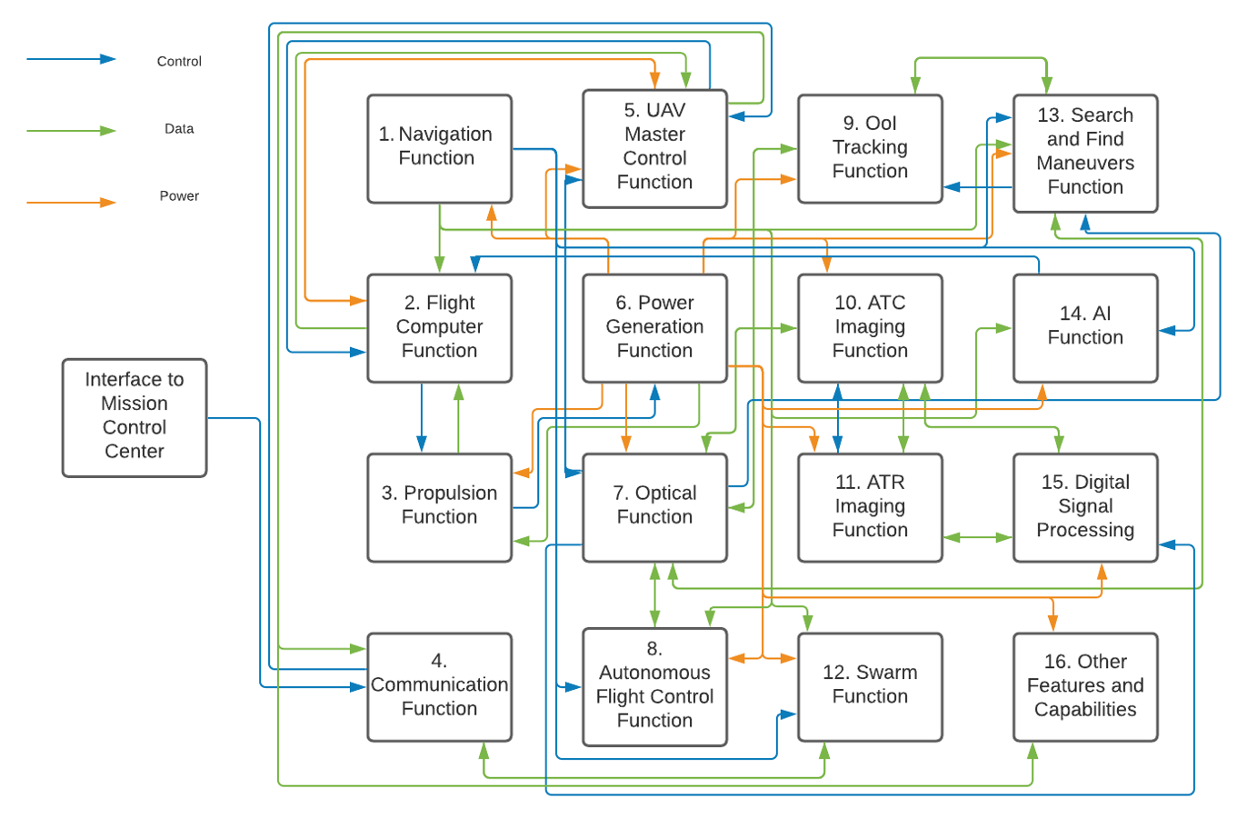

Figure 2: AUAV Functional Block Diagram

Typical mission functions include ~~manual and/or~~ autonomous flight control with manual override capability (depending on needs) with a specific target area in mind. The AUAV will be programmed with the desired target area boundaries in order to keep the system over the area of interest. While flying, the AUAV must perform collision avoidance, typical flight operations and maintain radio data links to transfer information back to the mission control center. The mission requires optical images of potential targets ~~to~~ ~~determine if U.S. Government agencies should be notified for law enforcement interdiction actions. The decision about notification of law enforcement is made by~~ to be to be sent to mission control center personnel who are evaluating the image information in near real time.

Functional Flow Diagram

Figure 03 displays the functional flow diagram using Visual Paradigm Process Flow Diagram software in which the AUAV’s functions interact at a high level. The Interface to the Mission Control Center will send commands to the AUAV which will be received by the Communication Function. Depending on the command received, the Communication Function will feed all commands to the UAV Master Control Function. The UAV Master Control Function will signal the Power Generation function to power to all functions nascency for the command to be initialized/completed. The UAV Master Control Function also sends the MCC’s command to all functions that are required for the task to be initialized/completed. The SWARM Function will take in data received from the Communication Function and the UAV’s Master Control function. The Optical Function will feed imagery data to the ATC to clean up the image. Once processed, the data will be passed to the ATR and then the Search & Find Function. The data will then be sent to the Tracking Function. The Flight Computer will take in data from the Tracking Function, SWARM Function, and any other functions in order to send necessary input to the Autonomous flight function which will send signals to the Navigation Function and Propulsion Function for the AUAV to perform the appropriate flight maneuvers (search & find and SWARM flight). 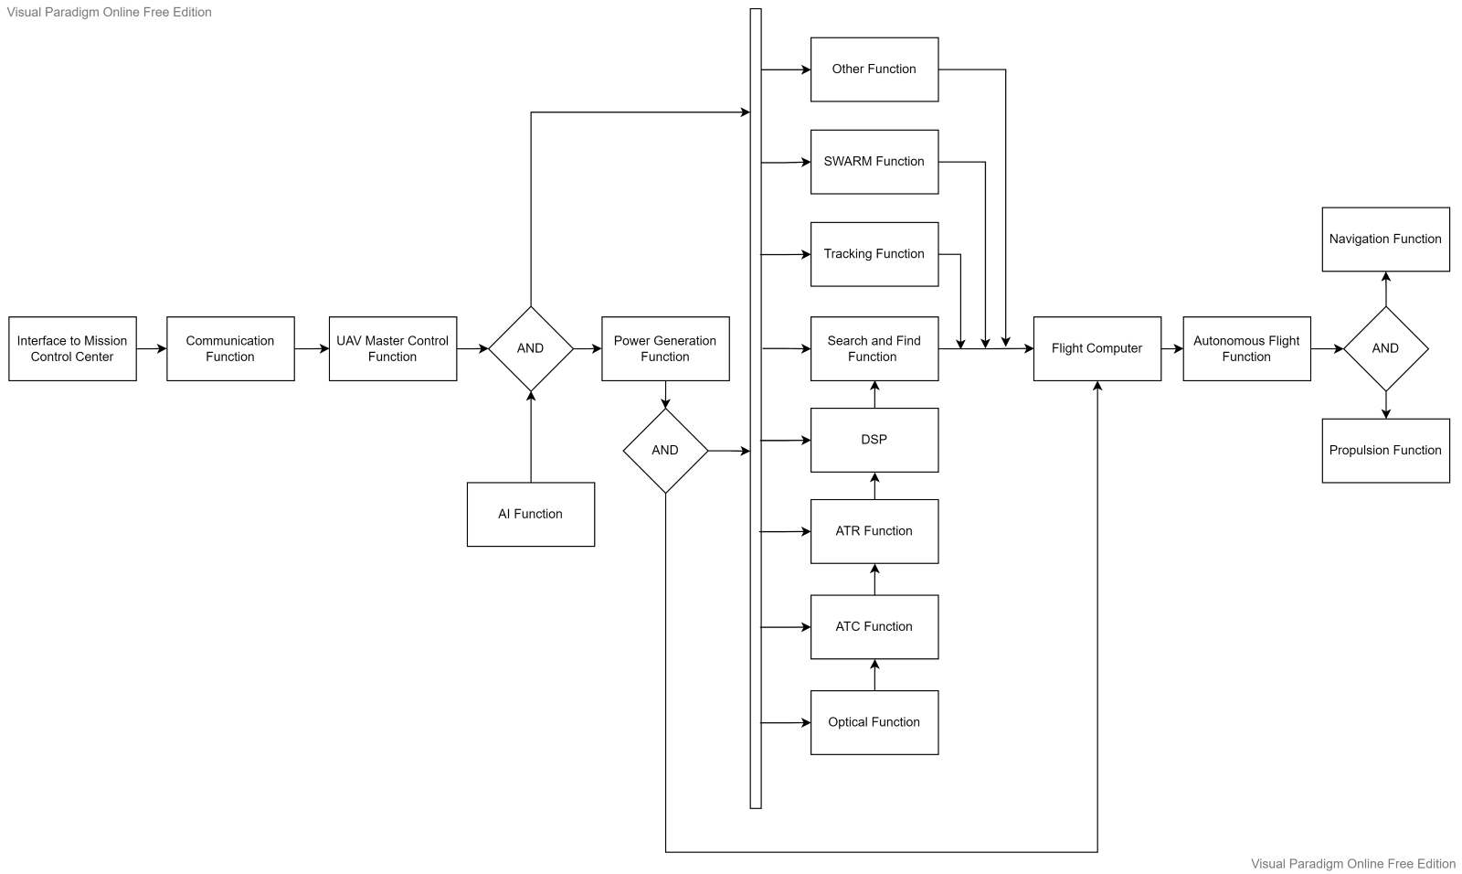

*Figure 10: Functional Flow Diagram*

### Requirements

* + - 1. The AUAV system shall be capable of automatic target recognition (ATR) of a biped from a processed image.
      2. The AUAV system shall be capable of sensing the AUAV’s pitch, roll and heading.
      3. The AUAV system shall be capable of sensing the AUAVs position relative to the ground.
      4. The AUAV system shall be capable of controlling the AUAV flight parameters autonomously to avoid collisions while in flight.
      5. The AUAV system shall regulate the incoming power voltage to prevent power surges.
      6. The AUAV system shall transform the incoming power voltage to suit components.
      7. The AUAV system shall be capable of changing from a fly-to location mission to an observe on station mission autonomously.
      8. The AUAV system shall be capable of changing from an observe on station mission to a fly-to location mission autonomously.
      9. The AUAV system shall be capable of changing from a fly-to location mission to a return to base mission autonomously.
      10. The AUAV system shall be capable of changing from an observe on station mission to a return to base mission autonomously.
      11. The AUAV system shall be capable of controlling the optical sub-system autonomously to set a detection scan pattern.
      12. The AUAV system shall be capable of controlling the optical sub-system automatically to set detection locations.
      13. The AUAV system shall be capable of adjusting the AUAV’s flight parameters autonomously to maneuver the AUAV while on the ground.
      14. The AUAV system shall be capable of adjusting the AUAV’s flight parameters autonomously to maneuver the AUAV from takeoff through landing.
      15. The AUAV system shall provide data storage for the mission weather map, fly-to-locations, optical parameters, and flight log.
      16. The AUAV system shall be capable of on-boarding images that selects the size of the image frames to transmit back to the mission command center.
      17. The AUAV system shall be capable of flying independently or as part of a SWARM of multiple AUAVs with adaptive, AI-based decision-making/mission reconfiguration.
      18. The AUAV shall be able to share information with other AUAVs based on the Information Exchange Requirement (IER) including position above the ground and altitude as well as imagery data.
      19. The AUAV shall contain a data link antenna and Tx/Rx capability with a data handling rate of 5MB/s (to transmit position/altitude/imagery).
      20. The AUAV shall be able to coordinate with other AUAVs in order to position themselves appropriately in the air to form a synthetic antenna array using Global Positioning System (GPS) and the data link.
      21. Each AUAV shall contain an antenna with adequate field of view and Electronic Warfare (EW)/communications receivers in order to process and identify the incoming signals and calculate a geolocation solution.
      22. The system shall be capable of overriding the AUAV controller to allow a live operator, way-points, and pre-programmed mission profiles.
      23. The AUAV system shall be capable of switching visibility mode between day, infrared radiation (IR) at night, and both selections for dawn and dusk.
      24. The AUAV system shall be capable of mission post processing.
      25. The AUAV system shall be capable of controlling object tracking.
      26. The AUAV system shall be capable of real time data transmission.
      27. The AUAV system shall be capable of GPS location inclusion for AUAV data.
      28. The AUAV system shall be capable of GPS location estimation.
      29. The AUAV system shall be capable of timestamp inclusion for AUAV data.
      30. The AUAV system shall be capable of integrating various modular sensor packages including magnetic sensing and infrasound sensing.
      31. The AUAV system shall be capable of compensating the distortions from images due to atmospheric turbulences.
      32. The AUAV system shall be able to toggle control between a remote control center, mobile command center, or A.I. Decision-making system.
      33. The AUAV shall be adaptable for other features/capabilities/sensor package/upgrade including a natural language, AI-based decision-making/mission reconfiguration.
      34. The integrated swarm of AUAVs shall be able to cooperatively intercept and geolocate Objects of Interest (OoI).
    1. ***Allocation of Requirements***
       1. The AUAV system shall have a navigation function.
       2. The AUAV system shall have a flight computer function.
       3. The AUAV system shall have a propulsion function.
       4. The AUAV system shall have a communications function.
       5. The AUAV system shall have a master control function.
       6. The AUAV system shall have a power generation function.
       7. The AUAV system shall have an optical function.
       8. The AUAV system shall have an autonomous flight controls function.
       9. The AUAV system shall have an object of interest function.
       10. The AUAV system shall have an atmospheric turbulence compensating imaging function.
       11. The AUAV system shall have an automatic target recognition function.
       12. The AUAV system shall have other features/capabilities/sensing packaging function.
       13. The AUAV system shall have an autonomous integrated swarm function.
       14. The AUAV system shall have a search and find maneuvers function.

### ***Functional Interfaces and Criteria***

* + - 1. The AUAV system shall provide target optical data to the mission control center.
      2. The AUAV system shall provide flight attitude information to the mission control center. (roll, pitch, yaw)
      3. The AUAV system shall provide GPS location information to the mission control center. (position, altitude)
      4. The AUAV system shall provide AUAV state of health information to the mission control center (fuel on board, system voltage, G force, collision avoidance).
      5. The AUAV system shall provide image processing interface for input/output of images ~~to search and find~~, digital signal processing (DSP), general purpose parallel processing, compression, resizing, and cropping of images.
      6. The AUAV system shall be capable of controlling light sensor interfaces for darkness/weather compensation, multipath compensation, control, dimming, noise calibration, filters.
      7. The AUAV system shall provide data storage interface for input/output of data, data handling, redundancy management, scaling, and indexing.
      8. The AUAV system shall provide sensor communication backbone interface for input/output communication, environmental interface handling, frame relay, checksum, and acknowledgement/error responses.
      9. The AUAV system shall provide communication interface for input/output communication, satellite communication, light of sight communication, mobile communication, rain fade, atmospheric latency compensation, phase modulation, transmission.
      10. The AUAV system shall interface with the existing AUAV mission control center to provide the best possible imaging technology and data processing for detection, identification, and tracking capabilities.

## ***System Characteristics***

### ***Performance Characteristics***

* + - 1. The AUAV system shall have a cold start time of a maximum of 30 seconds.
      2. The AUAV system shall have a hot start time of a maximum of 5 seconds.
      3. The AUAV system shall have a data transfer rate of a maximum of 150 Megabits/sec.
      4. The AUAV system shall operate at full performance for all temperatures ranging from -70.0 degrees Fahrenheit [-56.67 degrees Celsius] to +120.0 degrees Fahrenheit [+48.9 degrees Celsius], inclusively.
      5. The AUAV system shall operate at full performance for all atmospheric pressures ranging from -9.0 pounds per square inch absolute [-62.1 kilopascals absolute] and 0.0 pounds per square inch absolute [0.0 kilopascals absolute], inclusively.
      6. The AUAV system shall be able to control the AUAV flight speed from 0.0 miles per hour [0.0 kilometers per hour] to 158.45 miles per hour [255.00 kilometers per hour], inclusively, within a tolerance of +/- 5 miles per hour [8 kilometers per hour].
      7. The AUAV system shall be able to control the AUAV flight altitudes from ground level to a maximum of 15240 meters above mean sea level [15.240 kilometers], inclusively, with a tolerance of +/- 0.914 meters.
      8. The AUAV system shall be able to control the AUAV flight spatial position (latitude and longitude) with a tolerance of +/- 0.914 meters.
      9. The AUAV system shall prevent the AUAV from experiencing g-forces greater than 0.5 in the negative direction.
      10. The AUAV system shall prevent the AUAV from experiencing a bank angle greater than 40 degrees.
      11. The AUAV system shall position the optical sensors at its target location within a tolerance of +/- 0.610 meters.
      12. The AUAV system shall be able to control the magnification of the electro-optical sensor from 1 time to 25 times magnification, inclusively, with a tolerance of +/- 0.5 millidegrees.
      13. The AUAV system shall be able to assess an image for a target / no-target decision within a maximum time of 1 second from receiving the image.
      14. The AUAV system shall have a 90% positive target detection rate.
      15. The AUAV system shall determine optimal flight control settings within a maximum time of 200 milliseconds.
      16. The AUAV system shall determine optimal optical control settings within a maximum time of 200 milliseconds.
      17. The AUAV system shall detect a ground-based obstacle entering its sphere of influence within of 0.5 seconds.
      18. The AUAVs sphere of influence shall be 3.658 m +/- 0.914 m. while on the ground.
      19. The AUAV system shall detect human Target of Interest (TOI) with a slant range of 9.543km during daytime.
      20. The AUAV system shall detect human Target of Interest (TOI) with a slant range of 1.5 km during nighttime.
      21. The AUAV system shall identify human Target of Interest (TOI) with a slant of 1.5 km during daytime.
      22. The AUAV system shall identify human Target of Interest (TOI) with a slant range of 250 m during nighttime (with slipstream sensors).
      23. The AUAV system shall identify human Target of Interest (TOI) within a slant range of 1.5km (with slipstream sensor).
      24. The AUAV system shall provide an image/dataset to command center within 5 seconds.
      25. The AUAV system shall provide on-demand video to command center within 5 seconds.
      26. The AUAV system shall provide detection 24 hours per day / 7 days per week with a 98% operational availability during on-station time.
      27. The AUAV system shall observe a nominal 10 km by 10 km swatch centered on each hot-spot location.
      28. The AUAV system shall also be able to search a large grid within a 256 km by 256 km range associated with each hot spot.
      29. The AUAV system shall have an optical system that can detect human heat in the IR with a peak wavelength of 9.5 micrometers.
      30. The AUAV system shall process atmospheric turbulence compensation video data on streaming data at video rate of 30 Hz, or on individually selected images.

### ***Physical Characteristics***

* + - 1. The AUAV system shall not exceed 66 feet wide x 36 feet long x 12.5 feet high [ 20.11m x 10.97 m x 3.81 m]
      2. The AUAV system weight shall not exceed 4,901 pounds [2,223 kilograms].
      3. The AUAV system shall include an optical system that consists of a telescope, relay optics and detectors.
      4. The AUAV system shall have filter wheels to apply notch filters, high pass, low pass, optical modulators (for background suppression), and specialized filters.
      5. The AUAV system shall have vibration and shock isolators.
      6. The AUAV system shall have an optical system with anti-reflection coatings for the optical surfaces.
      7. The AUAV system shall have an atmospheric turbulence compensating system with light captured at least at two wavelengths simultaneously.
      8. The AUAV system shall have an image parallel processing interface with fast memory, and long-term storage.
      9. The AUAV system shall look like a benign search and rescue AUAV, in color and geometry.

### ***Effectiveness Requirements***

* + - 1. The AUAV system shall maintain an Operational Availability of at least 98% during on-station time.
      2. The AUAV system shall be capable of Operational Availability to increase software robustness and redundancy to maximize operation time.

### ***Reliability***

* + - 1. The AUAV system shall have an Instantaneous Reliability of at least 70%.
      2. The AUAV system shall have a Mean Time Between Failure (MTBF) of 20 years.
      3. The AUAV system mean time to repair (MTTR) shall be a maximum of 8 hours.

### ***Maintainability***

* + - 1. The AUAV system shall not result in down time of more than 5 hours due to regular system maintenance.
      2. The AUAV system shall require complete system inspection after every 1000 hours of flight time.
      3. The AUAV system shall self-check and perform software updates when needed 5 hours prior to operation time.
      4. The AUAV system shall allow for 30 minute software updates of software by maintenance personnel.
      5. The AUAV system shall have a built-in-test (BIT) protocol incorporated into the controller to allow for easier maintenance.
      6. The AUAV system BIT function shall store BIT error files onto onboard memory.
      7. The AUAV system shall transmit BIT error files to the mission control center within 30 seconds of receipt of error.
      8. The company shall maintain the capability of repairing individual modules. That is if a module (Line Replaceable Unit, LRU) fails, it should be replaced with a spare at the customer site and the failed module transported to the factory where it can be repaired by personnel with high skill levels.
      9. All documentation for the maintenance schedules and procedures shall be provided for the system as part of the contractual deliverables.
      10. The system shall be maintained with Commercial Off the Shelf (COTS) tools and equipment.

### ***Usability (Human Factors)***

* + - 1. The AUAV system shall facilitate the operation of the AUAV intermediate skills. Intermediate skills in this case is defined as High School Graduate with 9th grade reading/writing level with no prior work experience and around 40 hours of training plus some on-the-job training.
      2. The AUAV system shall have a user friendly interface to minimize training and user skill requirements.
      3. The AUAV system shall include the user authorization procedure where users must identify themselves using log in name and password. Only users that are authorized have access to system data.

### ***Supportability***

* + - 1. The AUAV system shall support different data transfer protocols.
      2. The data processing, and control processing code from the AUAV systen shall be written with a programming language which is cross-platform.

### ***Transportability / Mobility***

* + - 1. The AUAV system shall accommodate ease of transport during system integration and maintenance.
      2. The AUAV system should not sustain damage while being transported.

### ***Flexibility***

* + - 1. The AUAV system shall be flexible such that changing mission requirements can be adapted into the operation.
      2. The AUAV system shall be designed to be flexible by making use of functional modularity that will allow for cost effective modification.
      3. The AUAV system shall support multifunctional tasking, including detection, oversight, and tracking.
      4. The AUAV system shall be reversible when the commander wants to update or cancel tasks.

### ***Sustainability***

* + - 1. The AUAV system shall be designed with system recycling in consideration.
      2. The AUAV system shall have the minimal infrared heat signature and acoustic emission to support environmental sustainability.
      3. The AUAV system shall have an optical system with environmental conditioning protection features (temperature regulators, moisture and humidity control, dust, pressure, and light shields).

### ***Safety***

* + - 1. The AUAV system shall not present any safety hazards to maintenance personnel.
      2. The AUAV system shall maintain constant transponder communication visible to all aircraft and Air Traffic Control to maintain air traffic safety.
      3. The AUAV system shall allow the transponder unimpeded communication without interference.
      4. Personal protective equipment (PPE) shall be worn as necessary i.e. repairs, noise levels, low oxygen environments, etc.
    1. ***Security***
       1. The AUAV system shall incorporate secure data encryption with the communication between the UAV and the mission control center.
       2. The AUAV system shall incorporate secure data encryption for all stored data (mission planning files, flying logs, maps).
       3. The AUAV system shall incorporate a special security token to modify or upload new software to the controller modules.
       4. The AUAV shall notify mission control as it approaches near international borders and airspaces, and other no-fly zones.
       5. The AUAV system shall report operational data, including battery information and functional performance in the event of an attack.
       6. The AUAV system shall be tamper-proof.
       7. The AUAV system shall data clear.
       8. The AUAV system shall support data security to prevent data theft.
       9. The AUAV system shall prevent GPS jamming.
       10. The AUAV system shall be capable counter Electronic Warfare (EW).

## ***Design and Construction***

### ***CAD/CAM Requirements***

* + - 1. All dimensioning shall be presented as imperial units with metric units presented in brackets after the imperial units.
      2. Electrical design drawings shall be modeled on software compatible with Autodesk AutoCAD.
      3. Mechanical design drawing shall be modelled on software compatible with PTC Creo Parametric.
      4. Mechanical failure analysis shall be modelled on software compatible with Ansys Workbench.
      5. Logical simulations shall be modelled on software compatible with MATLAB.
      6. Testing software scripts shall be generated on software compatible with MATLAB.

### ***Materials, Processes, and Parts***

* + - 1. The AUAV system shall incorporate standard hardware fasteners to maintain uniformity with the preexisting hardware.
      2. The AUAV system shall incorporate materials that resist corrosion during all operational modes.
      3. The AUAV system shall use approved processes dictated by the FAA for aerospace application.

### ***Mounting and Labelling***

* + - 1. Electrical components shall be labeled with regulatory classification statements.
      2. Electrical component input and output pinouts shall be identified with identification labels.
      3. Electrical components shall be labeled with safety warnings.
      4. All components should be labeled with manufacturer make and model.
      5. Hardware mounting shall be conducted with proper safety procedures and Personal Protective Equipment (PPE).
      6. Hazardous materials and safety hazards or adverse conditions shall be labeled visibly to personnel.

### ***Electromagnetic Radiation***

Electromagnetic radiation or Electric and Magnetic Fields (EMF) will be present in small amounts due to the inherent nature of the electronics within the housing. To retain full control and reliability of the controller and its constituent parts, this requirement is necessary.

* + - 1. No element of the AUAV system shall emit electromagnetic radiation levels of more than 5 milligauss.

### ***Interchangeability***

* + - 1. The AUAV system shall be designed using interchangeable parts or modules, line-replaceable units (LRUs), that can be easily switched when repairs arise.

### ***Workmanship***

* + - 1. Workmanship standards for material selection and manufacturing processes shall conform to the quality standards of the client.

### ***Testability***

* + - 1. The developed system shall be capable of being tested by the Supplier and Client software engineering teams.

### ***Economic Feasibility***

* + - 1. The AUAV system shall have a maximum cost of USD $69 million each unit for 22 UAVs.
      2. The AUAV should utilize commercial off the shelf products (COTS) where possible to reduce risk and cost.

## ***Documentation / Data***

* + 1. Maintenance schedules and procedures shall be included as part of the contractual deliverables to the Client in the final acceptance documentation.

## ***Logistics***

### ***Maintenance Requirements***

* + - 1. The AUAV should be supported and maintained throughout the program’s lifecycle over 25 years after delivery with pre-planned program improvements.

### ***Supply Support***

* + - 1. All vendors shall support the supplied product for the life of the UAV program.
      2. All contractors shall support the product for the life of the UAV program.

### ***Test and Support Equipment***

* + - 1. Software support utilities shall be developed for unit testing and verification and for debugging procedures.

### ***Personnel and Training***

* + - 1. A user interface document shall be developed for the training of UAV operators.
      2. A user interface document shall be developed for the training of maintenance personnel.

### ***Facilities and Equipment***

* + - 1. The AUAV system shall conform to all UAV facility and applicable equipment standards.
      2. The mobile command center shall have a power source that meets the AUAV operator’s needs.

### ***Packaging, Handling, Storage and Transportation***

The entirety of the system is very fragile and susceptible to damage from vibration, heat and electromagnetic discharge while not housed in UAV system infrastructure. Care should be exercised when unit is being transported from within the facility or to other remote locations.

* + - 1. Loose electrical components shall be packaged in Electrostatic Discharge (ESD) protected packaging.
      2. Loose components shall be placed in temporary frames that are guarded from shock.
      3. All transportation personnel shall receive sufficient training on handling of the components.
      4. Components shall be stored in a climate-controlled environment.
      5. All components and assemblies etc. will be logged and managed by personnel with signatures for tracking movement of storage items in and out of the facility.
    1. ***Computer Resources***
       1. The AUAV system utilities, test and support equipment, computers for managing data and all other tools shall be compatible with Windows 10 OS or later.

### ***Technical Data***

* + - 1. A quality control dossier shall be created per UAV.
      2. An Operation Manual shall be created per site.
      3. A Maintenance Manual shall be created per site.
      4. One (1) copy of software test results shall be included in the handover Quality Control documentation.
      5. One (1) copy of mechanical test result data shall be included in the handover Quality Control documentation.
      6. Four (4) copies of the Operation Manual shall be included in the handover documentation.
      7. Four (4) copies of the Maintenance Manual shall be included in the handover documentation.
      8. One (1) copy of the system design dossier shall be included in the handover documentation.
      9. One (1) copy of the As-installed Software shall be included in the handover documentation.

### ***Customer Service***

* + - 1. The Supplier shall provide a customer support contact number which shall be staffed 24 hours a day to log and respond to queries.

## ***Producibility***

* + 1. The AUAV system shall be producible using manufacturing documents and include dimensions and tolerances.
    2. Standardization of the production process and tool sign-out and sign-in sheets must be used to ensure quality.
    3. The software shall be downloadable.
    4. The software shall be able to be installed by a trained user.

## ***Disposability***

The proper disposal of the system and its component parts is important to ensure data security and that no substances are released that are harmful to human health and the environment.

* + 1. Components shall be properly sanitized prior to disposal.
    2. All data storing hardware shall be re-formatted prior to disposal.
    3. Any salvageable materials should be sold or processed for reuse with a servicing plan.
    4. Components will be separated based on disposal type and any potentially hazardous materials labeled as such based on Safety Data Sheets.
    5. A log of the storage inventory must be kept and signed by the appropriate trained personnel.

## ***Affordability***

The success of the autonomous UAV project requires that the system remain cost competitive.

* + 1. The AUAV system shall be cost competitive when compared to its peer group.

# ***Test and Evaluation***

System testing and evaluation shall be conducted during each phase of the system life cycle. The system shall be tested in a tiered approach, verifying each of the system requirement of the system requirements described in Section 3, while also validating the functionality of the system. The following types of testing shall be performed:

Analytical and Simulation Evaluation: This involves evaluation and analysis of computer simulations for various system components.

Type 1 Testing: Evaluation of initial models and development builds for the component software. Testing shall be performed at the Supplier’s facilities using Supplier’s test tools and resources.

Type 2 Testing: Evaluation of the system prototype and initial integration of the system components. Testing shall be performed at the Supplier’s facilities using the Supplier’s test tools and resources.

Type 3 Testing: Evaluation of the final implementation of the system. Testing shall be conducted at the Supplier’s facilities and Client’s base of operations using the Supplier’s test tools and resources.

Flight Test: Full demonstration of capability needed in the field during operational assessment.

Qualification by Analysis: Full testing is not needed due to legacy hardware/software uses and Technology readiness level (TRL), but analysis is needed to verify specific use case of this program and integration architecture allows HW/SW to still perform to spec.

Qualification by Similarity: Lower-level, less intensive analysis is needed to show legacy hardware/software has meet these requirements in the past and is currently employed in a way that allows identical functionality.

|  |  |  |
| --- | --- | --- |
| Requirement | Method for Verification | Reasoning |
| 3.1.4.1 | Flight Test | Full field demonstration of capability needed |
| 3.1.4.2 | Flight Test | Full field demonstration of capability needed |
| 3.1.4.3 | Flight Test | Full field demonstration of capability needed |
| ~~3.1.4.4~~ | ~~Flight Test~~ | ~~Full field demonstration of capability needed~~ |
| ~~3.1.4.5~~ | ~~Flight Test~~ | ~~Full field demonstration of capability needed~~ |
| 3.1.4.6 | Flight Test | Full field demonstration of capability needed |
| 3.1.4.7 | Qualification by Similarity | Small less extensive analysis will be needed to verify since leveraged hardware has high TRL and success rate, analysis needed to ensure functionality with unique integration/application relative to this program |
| 3.1.4.8 | Qualification by Similarity | Small less extensive analysis will be needed to verify since leveraged hardware has high TRL and success rate, analysis needed to ensure functionality with unique integration/application relative to this program |
| 3.1.4.9 | Flight Test | Full field demonstration of capability needed |
| 3.1.4.10 | Flight Test | Full field demonstration of capability needed |
| 3.1.4.11 | Flight Test | Full field demonstration of capability needed |
| 3.1.4.12 | Flight Test | Full field demonstration of capability needed |
| 3.1.4.13 | Flight Test | Full field demonstration of capability needed |
| 3.1.4.14 | Flight Test | Full field demonstration of capability needed |
| 3.1.4.15 | Flight Test | Full field demonstration of capability needed |
| 3.1.4.16 | Flight Test | Full field demonstration of capability needed |
| ~~3.1.4.17~~ | ~~Flight Test~~ | ~~Full field demonstration of capability needed~~ |
| ~~3.1.4.18~~ | ~~Flight Test~~ | ~~Full field demonstration of capability needed~~ |
| 3.1.4.19 | Qualification by Analysis | Leveraged hardware will be high TRL but final capability verified by detailed analysis |
| ~~3.1.4.20~~ | ~~Qualification by Analysis~~ | ~~Leveraged hardware will be high TRL but final capability verified by detailed analysis~~ |
| ~~3.1.4.21~~ | ~~Qualification by Analysis~~ | ~~Leveraged hardware will be high TRL but final capability verified by detailed analysis~~ |
| ~~3.1.4.22~~ | ~~Qualification by Analysis~~ | ~~Leveraged hardware will be high TRL but final capability verified by detailed analysis~~ |
| 3.1.4.23 | Qualification by Analysis | Leveraged hardware will be high TRL but final capability verified by detailed analysis |
| ~~3.1.4.24~~ | ~~Qualification by Analysis~~ | ~~Leveraged hardware will be high TRL but final capability verified by detailed analysis~~ |
| 3.1.4.25 | Flight Test | Full field demonstration of capability needed |
| 3.1.4.26 | Flight Test | Full field demonstration of capability needed |
| 3.1.4.27 | Flight Test | Full field demonstration of capability needed |
| 3.1.4.28 | Flight Test | Full field demonstration of capability needed |
| 3.1.4.29 | Flight Test | Full field demonstration of capability needed |
| 3.1.4.30 | Flight Test | Full field demonstration of capability needed |
| 3.1.4.31 | Flight Test | Full field demonstration of capability needed |
| 3.1.4.32 | Flight Test | Full field demonstration of capability needed |
| ~~3.1.4.33~~ | ~~Flight Test~~ | ~~Full field demonstration of capability needed~~ |
| 3.1.4.34 | Flight Test | Full field demonstration of capability needed |
| 3.1.4.35 | Flight Test | Full field demonstration of capability needed |
| 3.1.4.36 | Qualification by Analysis | Leveraged hardware will be high TRL but final capability verified by detailed analysis |
| 3.1.4.37 | Qualification by Analysis | Leveraged hardware will be high TRL but final capability verified by detailed analysis |
| 3.1.4.38 | Qualification by Analysis | Leveraged hardware will be high TRL but final capability verified by detailed analysis |
| ~~3.1.4.39~~ | ~~Qualification by Similarity~~ | ~~Hardware used to accomplish this will be leveraged and already at high TRL~~ |
| 3.1.4.40 | Qualification by Similarity | Hardware used to accomplish this will be leveraged and already at high TRL |
| 3.1.4.41 | Qualification by Similarity | Hardware used to accomplish this will be leveraged and already at high TRL |
| 3.1.4.42 | Flight Test | Full field demonstration of capability needed |
| 3.1.4.43 | Flight Test | Full field demonstration of capability needed |
| 3.1.4.44 | Flight Test | Full field demonstration of capability needed |

# ***Quality Assurance Provisions***

All system level tests will be witnessed by representatives of the Supplier’s Quality Assurance discipline along with the software engineering and systems engineering teams to ensure the test procedures are conducted as documented.

All inspection and testing documentation shall be provided to the Client in the final acceptance documentation.

# ***Distribution and Customer Service***

The system shall be installed within, and integrated into, the UAVs existing systems at Supplier’s workshop by Supplier’s personnel. The Client’s technicians shall be invited to witness all applicable Type 1, 2 and 3 testing. Aerial acceptance testing and hand-over shall be performed at the original base of operations.

Supplier shall provide 2-days of onsite training for the technicians and operators as each UAV location. Operation and Maintenance manuals shall be provided for each UAV. Supplier shall provide a 1-year warranty on parts and workmanship. Additionally, the Supplier shall provide a customer support contact number which shall be staffed 24 hours a day to respond to queries.

# ***Acronyms***

|  |  |
| --- | --- |
| AI | Artificial Intelligence |
| AIS | Autonomous Integrated Swarm |
| ATC | Atmospheric Turbulence Compensating |
| ATF | The Bureau of Alcohol, Tobacco, Firearms |
| ATR | Automatic Target Recognition |
| AUAV | Autonomous Unmanned Aerial Vehicle |
| BIT | Built-In-Test |
| CAD | Computer-Aided Design |
| CAM | Computer-Aided Manufacturing |
| CONOPS | Concept of Operations |
| COTS | Commercial Off the Shelf |
| DEA | Drug Enforcement Administration |
| DSP | Digital Signal Processing |
| EMF | Electric and Magnetic Fields |
| ESD | Electrostatic Discharge |
| EW | Electronic Warfare |
| FAA | Federal Aviation Administration |
| FCC | Federal Communications Commission |
| FIT | Futuristics Innovation Technologies |
| GPPP | General Purpose Parallel Processing |
| GPS | Global Positioning System |
| IER | Information Exchange Requirement |
| IFoV | Instantaneous Field of View |
| IR | Infrared Radiation |
| LRU | Line Replaceable Unit |
| MATLAB | Matrix Laboratory |
| MCC | Mobile Command Center |
| MTBF | Mean Time Between Failure |
| MTTR | Mean Time to Repair |
| OoI | Object of Interest |
| PPE | Personal Protective Equipment |
| PTC | Parametric Technology Corp. |
| TOI | Target of Interest |
| TRL | Technology Readiness Level |
| UAS | Unmanned Aircraft Systems |
| UAV | Unmanned Aerial Vehicle |
| US | United States |
| GMLRS | Guided Multiple Launch Rocket System |
| ATACMS | Army Tactical Missile System |

# ***References***

Project Sky Net Design Dossier Rev 12 September 1, 2020

1. ***Requirements Justifications***

The purpose of this appendix is to provide further information about some of the requirements to provide the designer the proper background and perspective to understand the respective requirement. This includes reasoning and thought-process used while considering certain requirements. Additionally, any sources consulted will be provided here for additional insight.

Requirement 3.2.2.1: The system shall not exceed 66 feet wide x 36 feet long x 12.5 feet high [ 20.11m x 10.97 m x 3.81 m]

Justification: Based on the specifications of the General Atomics MQ-1 Predator, on which the design of this AUAV is based on, the dimensions are feasible and confirmed.

The system weight shall not exceed 4,901 pounds [2,223 kilograms].

*Justification:**The*General Atomics MQ-1 Predator including the gross weight of the drone plus its full fuel capacity is 3100 lbs, 1801 lbs under the required limit. The optical sub-system has a max weight of 120 lbs. If 13 other functions such as shown in the functional block diagram have the same max weight and there is room to upgrade with 2 more functions (e.g.; natural language, AI-based Command and Control Interface), then the total weight comes to 4900 pounds which makes this requirement reasonable. We are assuming there are no onboard missiles installed on this AUAV by FIT.

See <https://en.wikipedia.org/wiki/General_Atomics_MQ-1_Predator> for more information.

Section 3.2.2 Requirements

Justification: Using FIT’s ATC and GPPP technology along with the provided parameters from the Optics expert, the requirements seem 100% feasible.

# 